Paper Abstract Format
(For Original Research)

Title (Font size 16)
Author’s Name ^{Numbering (superscript)} (Font size 14)
(Add more in case of multiple authors)
Numbering: Name of the Institute/University, Address. (Font size 12)
Abstract: (Font size 14)
Approximately 300 words briefing about the
- Introduction,
- Review of the literature,
- Particulars about the data collection,
- Methods and methodology adopted,
- Result obtained, and
- Conclusion derived. (Font Size 12)
Keywords: Mention a minimum of 5 keywords for delivering the idea of the paper. (Font size 12)

For Review Paper

Abstract: (Font size 14)
Approximately 300 words briefing about the
- Introduction,
- Review of the literature, and
- Conclusion derived. (Font Size 12)
Keywords: Mention a minimum of 5 keywords for delivering the idea of the paper. (Font size 12)

For more information kindly take a glimpse of the Academic Journal of Forensic Science,

https://www.xournals.com/academic-journal-of-forensic-sciences-1524563112/info/about

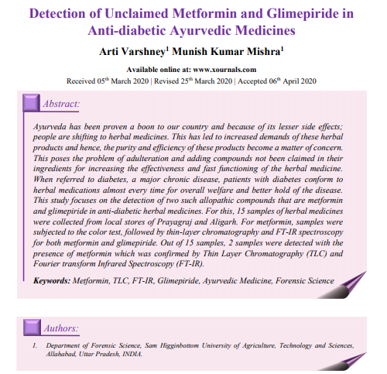
Have a look at it!! Here is a sample for your better understanding.

