Paper Abstract Format
(For Original Research)

Title (Font size 16)
Author’s Name ^{Numbering (superscript)} (Font size 14)
(Add more in case of multiple authors)
Numbering: Name of the Institute/University, Address. (Font size 12)
Abstract: (Font size 14)
A running paragraph in approximately 300 words briefing about the
Introduction, Review of the literature, Particulars about the data collection, Methods and methodology adopted, Result obtained, and Conclusion derived. (Font Size 12)
Keywords: Mention a minimum of 5 keywords for delivering the idea of the paper. (Font size 12)

For Review Paper

Abstract: (Font size 14)
A running paragraph in approximately 300 words briefing about the
Introduction, Review of the literature, and Conclusion derived. (Font Size 12)
Keywords: Mention a minimum of 5 keywords for delivering the idea of the paper. (Font size 12)

For more information kindly take a glimpse of the Academic Journal of Forensic Science,

https://www.xournals.com/academic-journal-of-forensic-sciences-1524563112/info/about

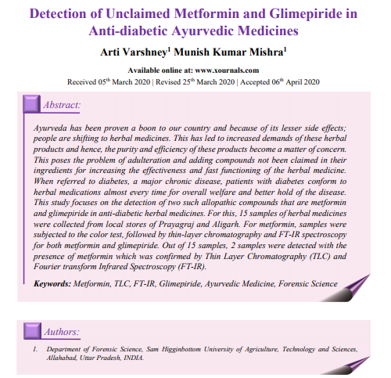
Have a look at it!! Here is a sample for your better understanding.

